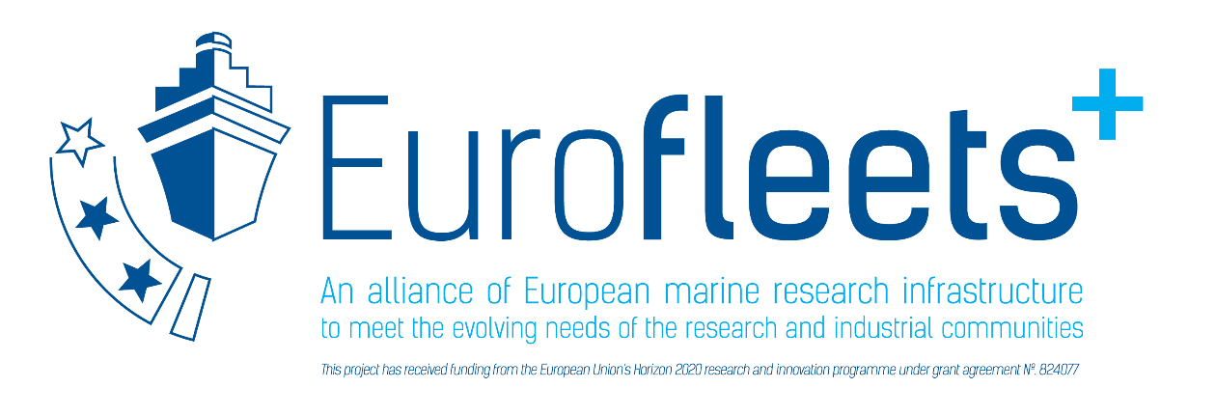

Cruise Report

PROJECT TITLE

Research vessel, Cruise No. XX,

DATE – DATE, Port of mobilistaion (Country) – Port of demobilisation (Country)

Project Logo / Picture etc.

AUTHORS
Table of Content
Page
1 Summary XX
2 Research objectives XX
3 Narrative of the Cruise XX
4 Preliminary Results XX
4.1 Underway Hydroacoustics XX
4.1.1 System Overview and Data Processing XX
4.2 Water and Plankton Sampling with CTD/Rosette XX
4.2.1 CTD Measurements and Sampling for Stable Isotopes XX
. XX
. XX
. XX
5 Data and Sample Storage/Availability XX
6 Participants XX
7 Station List MXX/Y XX
8 Acknowledgements XX
9 References XX

1 Summary
[Short paragraph summarizing the cruise.]
Lorem ipsum dolor sit amet, consectetuer adipiscing elit. Aenean commodo ligula eget dolor. Aenean massa. Cum sociis natoque penatibus et magnis dis parturient montes, nascetur ridiculus mus. Donec quam felis, ultricies nec, pellentesque eu, pretium quis, sem. Nulla consequat massa quis enim. Donec pede justo, fringilla vel, aliquet nec, vulputate eget, arcu.
In enim justo, rhoncus ut, imperdiet a, venenatis vitae, justo. Nullam dictum felis eu pede mollis pretium. Integer tincidunt. Cras dapibus. Vivamus elementum semper nisi. Aenean vulputate eleifend tellus. Aenean leo ligula, porttitor eu, consequat vitae, eleifend ac, enim.

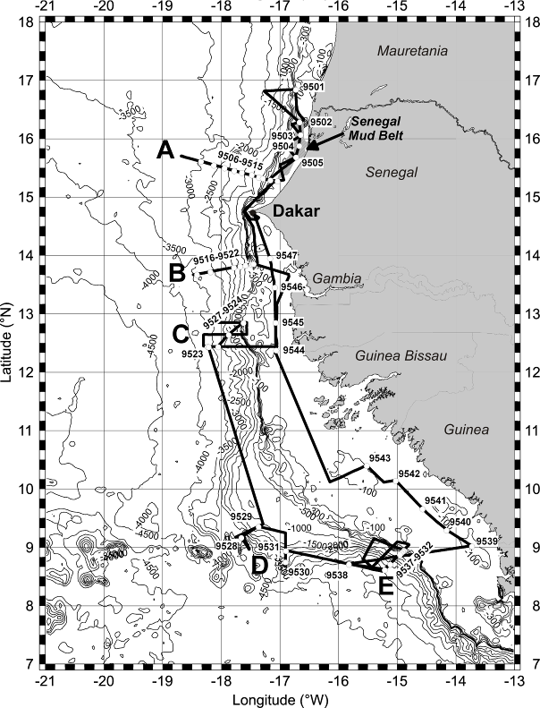
Fig. 1.1 Working area and track chart of R/V XY Cruise XY. Bathymetry from Smith and Sandwell (1997).

2 Research Programme/Objectives
Lorem ipsum dolor sit amet, consectetuer adipiscing elit. Aenean commodo ligula eget dolor. Aenean massa. Cum sociis natoque penatibus et magnis dis parturient montes, nascetur ridiculus mus. Donec quam felis, ultricies nec, pellentesque eu, pretium quis, sem. Nulla consequat massa quis enim. Donec pede justo, fringilla vel, aliquet nec, vulputate eget, arcu.
In enim justo, rhoncus ut, imperdiet a, venenatis vitae, justo. Nullam dictum felis eu pede mollis pretium. Integer tincidunt. Cras dapibus. Vivamus elementum semper nisi. Aenean vulputate eleifend tellus. Aenean leo ligula, porttitor eu, consequat vitae, eleifend ac, enim.

3 Narrative of the Cruise
[Describe the daily operations, from the moment the team boards the vessel. Describe/mention any activities relevant to the EUROFLEETS+ cruise, including safety trainings, preparation of equipment/sampling gear before reaching station. The format could be an extract from the daily log book related to the activities of EUROFLEETS+.
In addition, a table, with mobilisation/demobilisation, time/date of departure, station information (coordinates, arrival time/departure time), and time/date of cruise finalisation, clearly reflecting the days at sea.
Any activities onboard (sample processing, preparation of sampling gear, should be mentioned).]

Lorem ipsum dolor sit amet, consectetuer adipiscing elit. Aenean commodo ligula eget dolor. Aenean massa. (…) Donec pede justo, fringilla vel, aliquet nec, vulputate eget, arcu.
In enim justo, rhoncus ut, imperdiet a, venenatis vitae, justo. (…). Aenean vulputate eleifend tellus. Aenean leo ligula, porttitor eu, consequat vitae, eleifend ac, enim.

4 Preliminary Results
4.1 Underway Hydroacoustics (EXAMPLE)
(Brüning, M., Schulz, M. and Shipboard Scientific Party)
4.1.1 System Overview and Data Processing
Lorem ipsum dolor sit amet, consectetuer adipiscing elit. Aenean commodo ligula eget dolor. Aenean massa. (…) Donec pede justo, fringilla vel, aliquet nec, vulputate eget, arcu.
4.2 Water and Plankton Sampling with CTD/Rosette
4.2.1 CTD Measurements and Sampling for Stable Isotopes
(N. Gussone, A. Paul)
Lorem ipsum dolor sit amet, consectetuer adipiscing elit. Aenean commodo ligula eget dolor. Aenean massa. (…) Donec pede justo, fringilla vel, aliquet nec, vulputate eget, arcu.

etc.

5 Data and Sample Storage / Availability
Lorem ipsum dolor sit amet, consectetuer adipiscing elit. Aenean commodo ligula eget dolor. Aenean massa. Cum sociis natoque penatibus et magnis dis parturient montes, nascetur ridiculus mus. Donec quam felis, ultricies nec, pellentesque eu, pretium quis, sem. Nulla consequat massa quis enim. Donec pede justo, fringilla vel, aliquet nec, vulputate eget, arcu.

6 Participants
No. | Name | Early career (Y/N) | Gender | Affiliation | On-board tasks
1 | Fred Feuerstein |  | M | AWI | CTD work, Nutrient analysis,
2 | NN, Student |  | M | OGS | Seismics watch
3 | Etc.

IMPORTANT: Indicate participants funded by EUROFLEETS+, e.g. with an asterisks.
If any participant/science party from the EUROFLEETS+ cruise are not funded by EUROFLEETS+, please indicate it.
AWI Alfred Wegener Institute Helmholtz Centre for Polar and Marine Research, Bremerhaven, Germany
OGS National Institute of Oceanography and Experimental Geophysics, Trieste, Italy
...
[Please also add a list/table of remote participants, their tasks and role in processing the data/samples, if applicable].

7 Station List
Station No. | Date | Time | Latitude | Longitude | WaterDepth | Gear | Remarks/Recovery
 | 20XY | [UTC] | [°N] | [°W] | [m]
XY | 12.6. | 17:24 | 16°50.41 | 16°43.96 | 330 | ROS/CTD | 300-200-100-50-25-0 m
XY | 12.6. | 18:30 | 16°50.40 | 16°43.93 | 330 | ROS/CTD | CTD 10 m above rosette, 16 bottles, 300 m

8 Acknowledgements
Lorem ipsum dolor sit amet, consectetuer adipiscing elit. Aenean commodo ligula eget dolor. Aenean massa. Cum sociis natoque penatibus et magnis dis parturient montes, nascetur ridiculus mus. Donec quam felis, ultricies nec, pellentesque eu, pretium quis, sem. Nulla consequat massa quis enim. Donec pede justo, fringilla vel, aliquet nec, vulputate eget, arcu.

9 References
Sargent, J.R., 1976. The structure, metabolism and function of lipids in marine organisms. In: Malins, D.C., Sargent, J.R. (Eds.), Biochemical and Biophysical Perspectives in Marine Biology. Academic Press, London, pp. 149-212.
Smith, K.L., Ruhl, H.A., Kaufmann, R.S., Kahru, M., 2008. Tracing abyssal food supply back to upper-ocean processes over a 17-year time series in the northeast Pacific. Limnology and Oceanography 53, 2655-2667.

