Cruise Report

PROJECT TITLE

Research vessel, Cruise No. XX,

DATE – DATE, Port of mobilistaion (Country) – Port of demobilisation (Country)

Project Logo / Picture etc. (optionally)

AUTHORS
Table of Content
Page
1 Summary XX
2 Research objectives XX
3 Narrative of the Cruise XX
4 Preliminary Results XX
5 Data and Sample Storage/Availability XX
6 Participants XX
7 Station List/Sampling Sites XX
8 Acknowledgements XX
9 References XX

1 Summary
[Short paragraph summarizing the cruise.]
Lorem ipsum dolor sit amet, consectetuer adipiscing elit. Aenean commodo ligula eget dolor. Aenean massa. Cum sociis natoque penatibus et magnis dis parturient montes, nascetur ridiculus mus. Donec quam felis, ultricies nec, pellentesque eu, pretium quis, sem. Nulla consequat massa quis enim. Donec pede justo, fringilla vel, aliquet nec, vulputate eget, arcu.
In enim justo, rhoncus ut, imperdiet a, venenatis vitae, justo. Nullam dictum felis eu pede mollis pretium. Integer tincidunt. Cras dapibus. Vivamus elementum semper nisi. Aenean vulputate eleifend tellus. Aenean leo ligula, porttitor eu, consequat vitae, eleifend ac, enim.

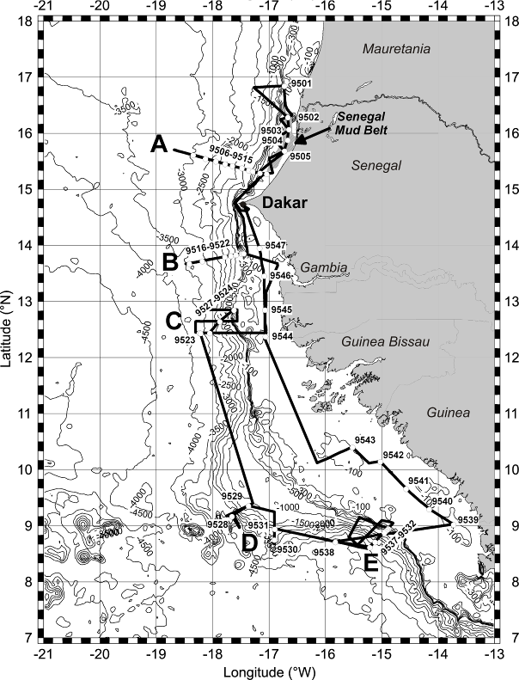
Fig. 1.1 Working area and track chart of R/V XY Cruise XY. Bathymetry from Smith and Sandwell (1997).

2 Research Programme/Objectives
[Short paragraph]
Lorem ipsum dolor sit amet, consectetuer adipiscing elit. Aenean commodo ligula eget dolor. Aenean massa. Cum sociis natoque penatibus et magnis dis parturient montes, nascetur ridiculus mus. Donec quam felis, ultricies nec, pellentesque eu, pretium quis, sem. Nulla consequat massa quis enim. Donec pede justo, fringilla vel, aliquet nec, vulputate eget, arcu.
In enim justo, rhoncus ut, imperdiet a, venenatis vitae, justo. Nullam dictum felis eu pede mollis pretium. Integer tincidunt. Cras dapibus. Vivamus elementum semper nisi. Aenean vulputate eleifend tellus. Aenean leo ligula, porttitor eu, consequat vitae, eleifend ac, enim.

3 Narrative of the Cruise
[Briefly describe the procedures carried out on board to obtain your samples or data]
Lorem ipsum dolor sit amet, consectetuer adipiscing elit. Aenean commodo ligula eget dolor. Aenean massa. (…) Donec pede justo, fringilla vel, aliquet nec, vulputate eget, arcu.
In enim justo, rhoncus ut, imperdiet a, venenatis vitae, justo. (…). Aenean vulputate eleifend tellus. Aenean leo ligula, porttitor eu, consequat vitae, eleifend ac, enim.

4 Preliminary Results
[Optionally]
Lorem ipsum dolor sit amet, consectetuer adipiscing elit. Aenean commodo ligula eget dolor. Aenean massa. (…) Donec pede justo, fringilla vel, aliquet nec, vulputate eget, arcu.

5 Data and Sample Storage / Availability
Lorem ipsum dolor sit amet, consectetuer adipiscing elit. Aenean commodo ligula eget dolor. Aenean massa. Cum sociis natoque penatibus et magnis dis parturient montes, nascetur ridiculus mus. Donec quam felis, ultricies nec, pellentesque eu, pretium quis, sem. Nulla consequat massa quis enim. Donec pede justo, fringilla vel, aliquet nec, vulputate eget, arcu.

6 Participants
[Please add a list/table of remote project participants and their tasks and role in processing the data/samples].
No. | Name | Early career (Y/N) | Gender | Affiliation | Project related tasks
1 | Fred Feuerstein |  | M | AWI | Nutrient analysis
2 | NN, Student |  | M | OGS
3 | Etc.

AWI Alfred Wegener Institute Helmholtz Centre for Polar and Marine Research, Bremerhaven, Germany
OGS National Institute of Oceanography and Experimental Geophysics, Trieste, Italy
...

7 Station List/Sampling Sites
Station No. | Date | Time | Latitude | Longitude | WaterDepth | Gear | Remarks/Recovery
 | 20XY | [UTC] | [°N] | [°W] | [m]
XY | 12.6. | 17:24 | 16°50.41 | 16°43.96 | 330 | ROS/CTD | 300-200-100-50-25-0 m
XY | 12.6. | 18:30 | 16°50.40 | 16°43.93 | 330 | ROS/CTD | CTD 10 m above rosette, 16 bottles, 300 m

8 Acknowledgements
Lorem ipsum dolor sit amet, consectetuer adipiscing elit. Aenean commodo ligula eget dolor. Aenean massa. Cum sociis natoque penatibus et magnis dis parturient montes, nascetur ridiculus mus. Donec quam felis, ultricies nec, pellentesque eu, pretium quis, sem. Nulla consequat massa quis enim. Donec pede justo, fringilla vel, aliquet nec, vulputate eget, arcu.

9 References
Sargent, J.R., 1976. The structure, metabolism and function of lipids in marine organisms. In: Malins, D.C., Sargent, J.R. (Eds.), Biochemical and Biophysical Perspectives in Marine Biology. Academic Press, London, pp. 149-212.

