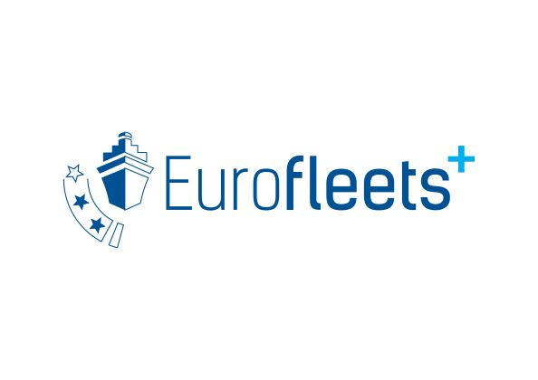
EurofleetsPlus KICK OFF MEETING AGENDA

5th – 7th March 2019
Marine Institute (MI), Rinville, Oranmore, Co. Galway, Ireland

Summary of Events by Day:
Date & Time | Activity | Location
Tuesday 5th March
Morning | Executive Committee Meeting/ Project Management Board (restricted to ExComm/PMB members)  WP9 Communications Meeting (Restricted to WP participants & invited members) | MI
Afternoon | Parallel Work Package Meetings – WP 3 (JRA 1, JRA3) (Data & AUV JRAs) , WP4 Call Management (restricted to WP participants & invited members) | MI
Evening | Ice Breaker Event (all participants) Galway City Museum | Galway City Museum
Wednesday 6th March
 | Welcome Addresses & Introductions  Intro to the Work Packages (all participants) | Auditorium
 | Financial processes, deliverables, reporting requirements (all participants) | Auditorium
Evening | Dinner (all participants) | Il Vicolo
Thursday 7th March
Morning | Stakeholder Engagement WP,  TNA Detail (AWI/MI)  Parallel Sessions:  New Beneficiaries/Participants  HelpDesk  WPs 3, 6, 7 and 8 meetings
Afternoon | Lunch and opportunity for further breakout meetings.

Tuesday March 5th 2019  Time | Activity | Location
09:15 – 11:00 | Executive Committee Meeting | Boardroom
11:00-11:30 | COFFEE BREAK
11:30 -13:00 | WP9 Dissemination & Communication Meeting | Boardroom
13:00 – 13:30 | Registration | MI Reception
13:30 – 14:30 | LUNCH | Coriolis Restaurant
14:30 – 17:00  Coffee Break @ 15:45 | 3 Parallel Work Package Meetings:  - WP 4 Call Management and Proposal Evaluation  - WP 3 JRA 3.1 Advancing shipboard data management systems and data access  - WP 3 JRA 3.3 (Intelligent Robot Exploration) | Rockall Meeting Room  Brendan the Navigator  Slyne Meeting Room
19:30 – 21:30 | Ice Breaker Social Event | Galway City Museum

Wednesday March 6th 2019  Time | Activity | Location
08:45-9:15 | Registration /Poster Installation | MI Reception
09:15 – 9:30 | Welcome Address – Peter Heffernan CEO Marine Institute | North Atlantic Drift Auditorium
09:30 – 10:00 | Welcome and Project overview & Details of Project Launch Event – Aodhán Fitzgerald (Project Coordinator) | Auditorium
10:00: 10:15 | VC with Agnes Robin – EC Project Officer | Auditorium
10:15 – 10:45 | TNA Calls, Call Management and Proposal Evaluation – Veronica Willmott (AWI) | Auditorium
10:45 – 11:00 | COFFEE/TEA
11:00 – 12:00 | New Beneficiaries Introductions - TNA Providers ( 5 minute presentation each)  SYKE, UGOT, IPMA, MFRI, NIOZ, NATO-CMRE, GEOMAR, NIWA, SOCIB, GFOE, UQAR, BIOS. | Auditorium
12:00 – 12:45 | Introduction to Work Package 3 JRAs x 3  - ‘Advancing shipboard data management systems and data access’ (15 mins)  - Equipment for Deep Sea Operations (15 mins)  - ‘Intelligent Robot Exploration’ (15 mins) – Rafael Garcia | Auditorium
12:45 – 13:20 | New Beneficiaries Introductions - Industry partners ( 5 minute presentation each)  VoyagerIP, Seaonics, Hampidjan, IQUA, MacArtney, CORONIS, BLIT | Auditorium
13:20 – 13:35 | Group Photo | Outside Auditorium
13:35-14:35 | Lunch | Coriolis Restaurant
14:35 – 14:50 | Work Package 5 Stakeholder Engagement & Introduction to EMSO-ERIC  Juanjo Dañobeitia (EMSO ERIC) | Auditorium
14:50 – 15:10 | Work Package 8 Foresight: Legacy and Roadmap – Giuseppe Magnifico (CNR) | Auditorium
15:10 – 15:30 | WP6 Education & Training activities presentation and Roadmap for the 1st year – Andrea Caburlotto (OGS) | Auditorium
15:30 – 16:00 | COFFEE BREAK
16:00 – 16:20 | Communications Plan, Website, Templates – Sandra Sa & Ruth Higgins (Eurocean) | Auditorium
16:20-16:35 | Work Package 7 Innovation Management & Exploitation – Serge Scory (RBINS) | Auditorium
16:35-17:00 | Financials, deliverables, reporting  Sharing documents (Sharepoint), Project handbook Bernadette Ni Chonghaile (MI) | Auditorium
17:00-17:15 | Next General Assembly Locations – 2020, 2021……. Aodhán Fitzgerald | Auditorium
19:30 | Dinner | Il Vicolo, Galway city

Thursday March 7th 2019  Time | Activity | Location
09:00 – 10:00 | Stakeholder Engagement WP5 participants’ meeting - Juanjo Dañobeitia | Auditorium
10:00- 11:00 | TNA Detail (MI/AWI)  (Aodhán Fitzgerald /Veronica Wilmott) | Auditorium
11:00 -11:30 | COFFEE
11:30 – 13:00  11:30 – 13:30 | Reporting/Financial HelpDesk session for new beneficiaries - Pauline Ni Fhlatharta – MI Funding Office  Parallel sessions:  - WP 8 Foresight: Legacy and Roadmap  - WP 6 Training & Education  - WP 3 - JRA 2 (Deep Sea Operations) Meeting  - WP 7 Innovation & Exploitation Management meeting | Auditorium  Erris Meeting Room  Brendan the Navigator  Porcupine Meeting Room  Slyne Meeting Room
13:30-14:30 | LUNCH | Coriolis Restaurant
14:30 - TBC | Additional WP meeting time / EMB working group meeting | Brendan the Navigator /Boardroom
14.30 | Bus departing for Galway City Centre

