EurofleetsPlus KICK OFF MEETING AGENDA
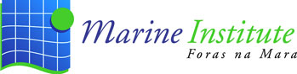

5th – 7th March 2019
Marine Institute (MI), Rinville, Oranmore, Co. Galway, Ireland
Brendan the Navigator

Parallel Session- WP6 “Training & Education”
Date & Time | Talk | Speaker
Thursday 7th March
11:30-11:35 | Opening of the session | Andrea Caburlotto
11:35-12:00 | Tasks presentation
 | Task 6.1 – Floating Universities | Andrea Caburlotto
 | Task 6.2 – Training & Education through Access and Exchange | Andrea Caburlotto
 | Task 6.3 – Blue skills labs & workshops | Andrea Caburlotto, Serge Scory & Urmas Lips
 | Task 6.4 – Remote access, e-learning and Ocean Literacy | Aodhan Fitzgerald
12:00-12:30 | Open questions and discussion  Participants target on Floating Universities  Time and organization of Writing Proposal workshop  Other | All
12:30-12:55 | Organization of 2019 Labs  Roadmap for 1st year | All
12:55-13:00 | Conclusion | Andrea Caburlotto

