EurofleetsPlus Kick-Off Meeting

5th – 7th March 2019

Marine Institute, Rinville, Oranmore, Co. Galway, Ireland H91 R673

PRACTICAL INFORMATION

How to get here?
From the Airport: You have the option to fly into either Dublin or Shannon Airport.

Dublin Airport
Dublin is 215km or 2.5 hours by car from Galway. There is a very good direct non-stop bus service so if flying to Dublin, this would be the recommended option. You can use one of the following companies - http://www.gobus.ie or http://www.citylink.ie. The Galway Bus station is in Galway city centre. You could also catch a train to Galway from Dublin’s Heuston Station (http://www.irishrail.ie/fares-and-tickets/dublin-galway). Heuston station is circa 30 minutes by taxi from Dublin airport, depending on traffic.
Airport Buses from Dublin
Citylink – www.citylink.ie
Dublin to Galway Route Return – tickets cost around €30.

GoBus - www.gobus.ie
Dublin to Galway Route Return – tickets cost around €30.

Bus Eireann – www.buseireann.ie
Dublin Airport to Galway Return – tickets cost around €30.

Travel time by bus from Dublin airport to Dublin can vary between two and half hours to three hours (some routes go through Dublin centre, others are direct routes from the airport to Galway). Please keep this in mind when booking your bus and plane tickets.

Trains from Dublin
Trains run from Dublin city to Galway city on a daily basis however you need to get a taxi from Dublin airport to Heuston Station in Dublin city. The taxi journey takes about 20mins. Train times and tickets are available on www.irishrail.ie . Train tickets cost about €35 and the journey takes about 2 and half hours.

Shannon Airport
Shannon is the closest airport to Galway - 85km or 1 hour 15 minutes by car. There is a bus route 51 which connects Shannon to Ennis and Galway (originates in Cork). Please see link:
http://www.buseireann.ie/inner.php?id=406&form-view-timetables-from=Shannon+Airport+%28Departures+Gate%29&form-view-timetables-to=Galway+%28Bus+Station%29&form-view-timetables-route=&form-view-timetables-submit=1
You can arrange car rental or schedule a Car/Mini-bus transfer - https://www.galwayshuttle.com/ Approx €95 each way or http://www.shannonairportcab.com/ Phone: +353 (0)61 471538
Car Hire
www.rentalcars.com/ireland
www.arguscarhire.ie
www.budget.ie

ACCOMMODATION

The below hotels are offering special rates for the event – Please reference ‘Eurofleets’ when making the reservation

Harbour Hotel
Bed & Breakfast rate €109
New Dock Road
Galway City
Tel: +353 91 894800
Email: stay@harbour.ie
Website: http://www.harbour.ie/

Galmont Hotel
Bed & Breakfast rate of €130 single occupancy and €140 double occupancy – Booking Reference Online and by phone: - Eurofleets
Lough Atalia Road
Galway City
H91 CYN3
Tel: +353 91 538 300
Email: reservations.galway@radissonblu.com
Website: www.radissonhotelgalway.com/

The House Hotel
Bed and Breakfast rate of €105 per night.
Lower Merchants Road,
The Latin Quarter,
Galway City
Tel: +353 91 538900
Email: info@thehousehotel.ie
Website: www.thehousehotel.ie

The Connacht Hotel
Bed and Breakfast rate of €80 per person (single occupancy)
Dublin Road
Galway
Tel: +353 91 381200
Email: reservations@theconnacht.ie
Website: https://www.theconnacht.ie

Here are some more of the larger hotels in Galway City:

https://www.claytonhotelgalway.ie

https://www.maldronhotelsandyroadgalway.com

https://www.menloparkhotel.com

https://www.jurysinns.com/hotels/galway

Below are 2 hotels outside Galway city but closer to the Marine Institute.

https://www.oranmorelodge.ie

https://ie.hotels.com/ho205578/maldron-hotel-oranmore-galway-oranmore-ireland/

MAP
The Marine Institute Headquarters are situated in Rinville, Oranmore approx. 10KM from Galway City. You will have to account for about 20 to 30 minutes taxi travel time from Galway City to Rinville.

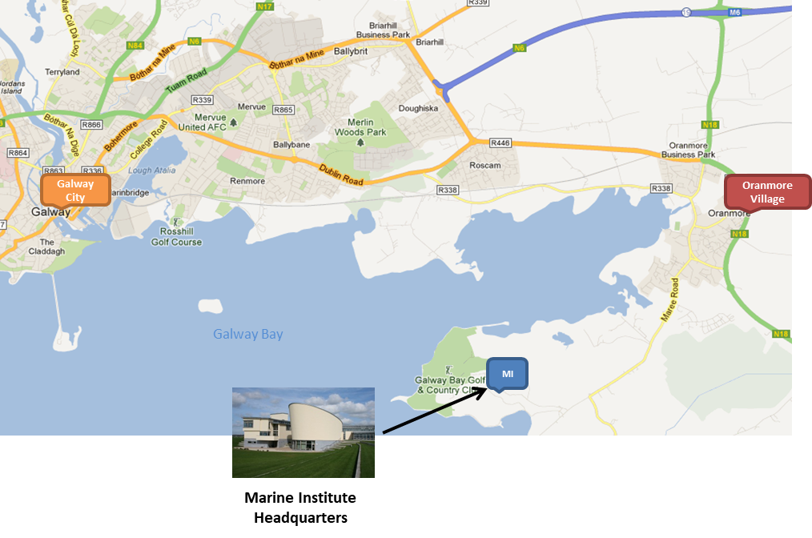
Daily Bus Service:
A shuttle bus service will pick up at the Harbour Hotel in the City centre each morning to bring attendees to the Marine Institute and drop them back to the city centre in the evening for the 3 days of the meeting. The Harbour Hotel is within walking distance of all hotels in the city centre – if you are staying outside of the city en-route to the Marine Institute and wish to avail of the shuttle bus please let us know – eurofleetsplus@marine.ie

Shuttle Bus Details:
Tuesday 5th: Departing Harbour Hotel @ 8:15am, departing Marine Institute @ 5pm for city centre.
Wednesday 6th: Departing Harbour Hotel @ 8:00am, departing Marine Institute @ 5:30pm for city centre.
Thursday 7th: Departing Harbour Hotel @ 8:15am, departing Marine Institute @ 2pm for city centre.
Car Parking: Visitors must use the car park at the golf club next door to the Marine Institute, as there is no space in the Marine Institute’s own car park. Keep going past the entrance to the Marine Institute and take the next entrance on the left into the Golf Club Car park – directly next door. Visitors can park here for free and do not need a pass to get in.
Lunch, teas/coffees & snacks will be served daily at the Marine Institute.
The Ice-Breaker Event will take place at the Kitchen Café at the Galway City Museum at 19:30 – 21:30 on Tuesday 05th March https://www.galwaycitymuseum.ie/.
The Gala Dinner will take place in Il Vicolo restaurant at 19:30 on Wednesday 6th March. https://www.ilvicolo.ie/
Maps of Galway city:
https://www.maps.ie/galway-city.htm
https://www.galwaytourism.ie/UserFiles/Image/galway-tourist-map.pdf

Restaurants in Galway City Centre
https://brasseriegalway.com/
http://kirwanslane.com/
http://www.oscarsseafoodbistro.com/
http://kaicaferestaurant.com/
http://www.johnkeoghs.ie/
Galway Taxis:
http://www.galwaytaxis.com/
http://www.bigotaxis.com/

